Luis Morales
CSCI 4321 - Computer Security
October 27, 2025
Lab 07 – ICMP Redirect Attack

Simulation network started:
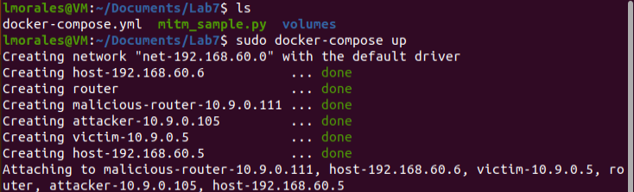

Task 1: Launching ICMP Redirect Attack

Victim before attack:
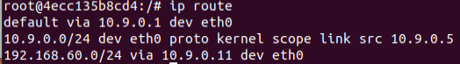
Victim after attack:
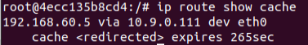

Failed redirect in different network:
